Maquette pour la plateforme d’échange

Enerbioflex

(23-11-16)

1. Page_recherche 2

2. Page_recherche_avancee 3

3. Page_detail_annonce 4

4. Page_deposition_annonce 5

5. Page_alerte 6

6. Page_alerte_annulation 7

7. Page_connection 8

8. Page_Inscription 9

9. Page_conditions_generales 10

1. Page_recherche

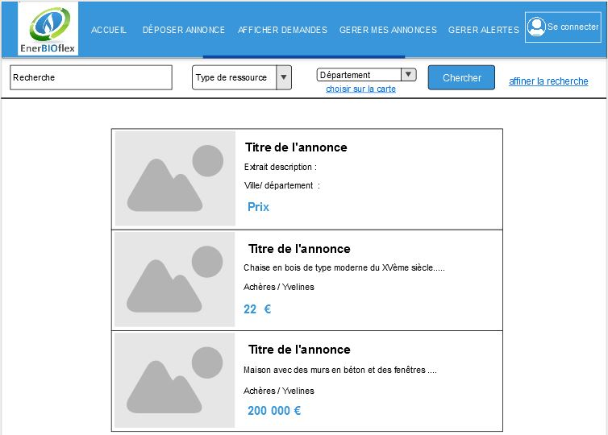

1. Page_recherche_avancee

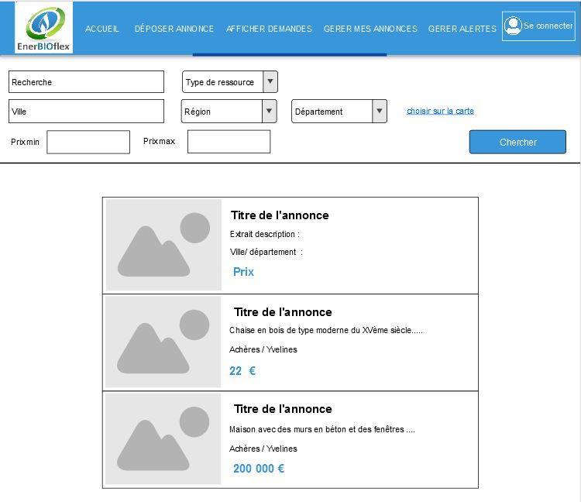

1. Page_detail_annonce

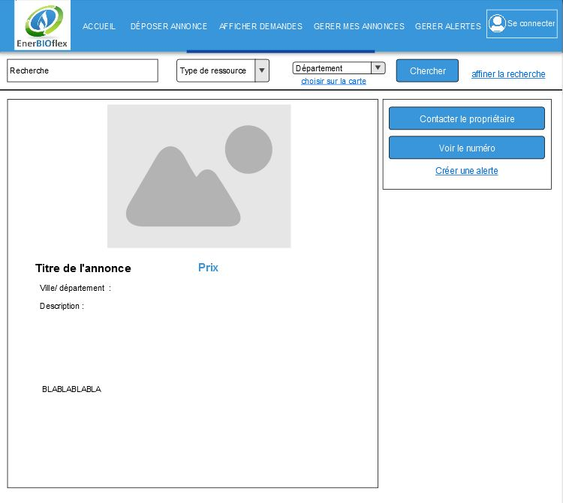

1. Page_deposition_annonce

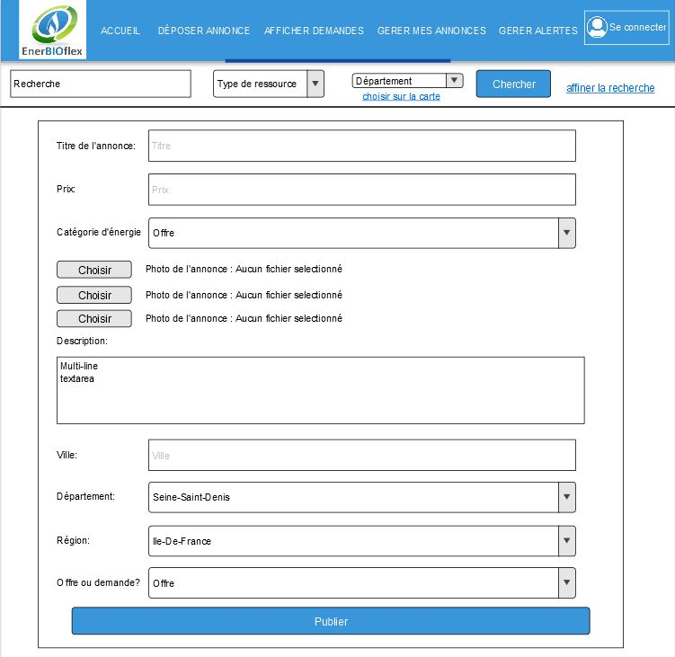

1. Page_alerte

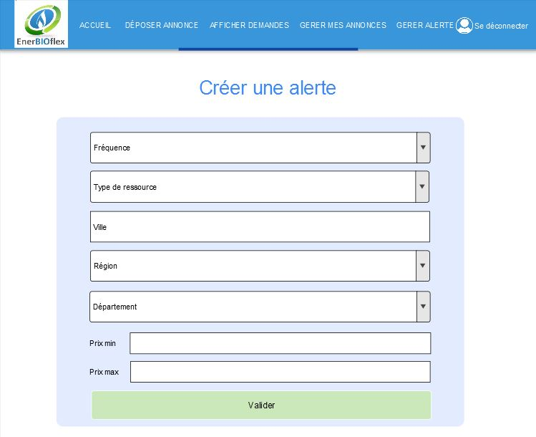

1. Page_alerte_annulation

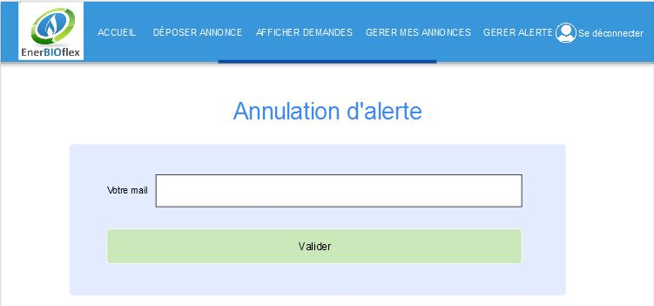

1. Page_connection

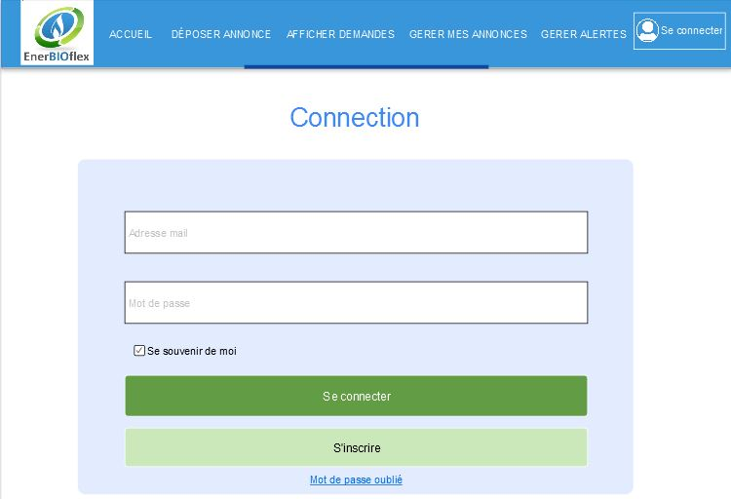

1. Page_Inscription

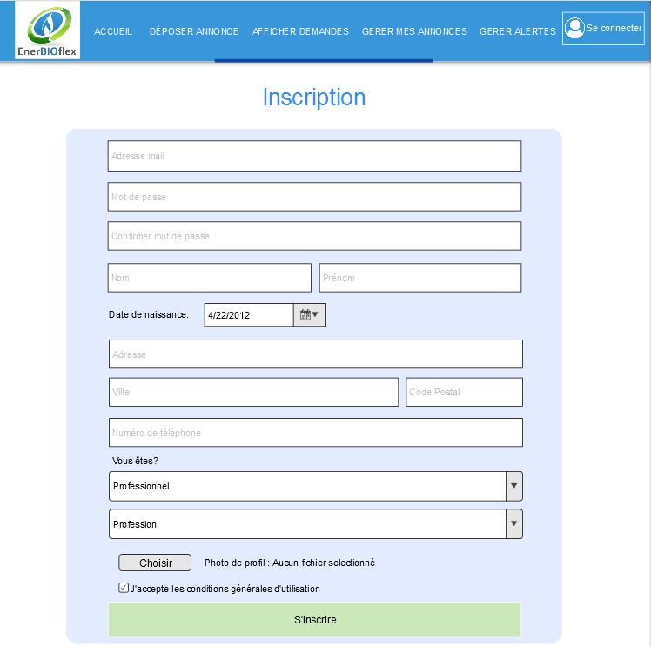

1. Page_conditions_generales

